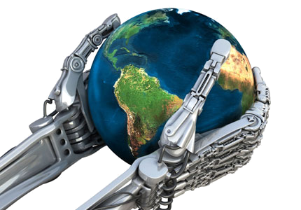

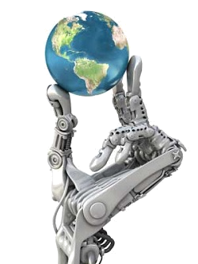
Buy fresh food that doesn’t need a lot of packaging.
Try to buy ‘organic’ fruit and vegetables from farmers who don’t use chemicals.

Reuse your grocery bags, or buy a string bag you can carry your groceries in.

Save as much water as possible.

Walk or ride a bike instead of using the car for short trips.

Use public transport as much as possible.

Replace incandescent bulbs with more efficient screw-in compact fluorescent bulbs.

Don’t buy products (fur or ivory) made from protected species.

Plant trees. They help prevent soil erosion and reduce air pollution.

Use fans instead of air conditioners.

Turn off lights in rooms you aren’t using.
Be sure to return your recyclable cans and bottles for your deposit.

Start an organic garden.

Try to throw away 25% less rubbish.
Don’t buy hamburgers or pizzas in plastic boxes which contain CFCs.
Try to save paper. Also buy and use recycled paper.
Use batteries as little as possible. It takes 50 times more energy to make them than they produce.
Don’t use excessive amounts of
detergent in your laundry.

Avoid throw-away products.
Use cold water
whenever possible for kitchen tasks and
laundry.

Find out more about Green Organisations in your area.

Laptop

Device

Wireless

Virtual

Texting

Bluetooth

Teleworking

E-learning

Earpiece

Java

Cell phone

Robot

Chip

SMS

WAP

Satellite

iPhone

GPS

Artificial Intelligence

Internet

4G cell phone




























A - It s a general purpose programming language with a number of features that make the language well suited for use on the World Wide Web.
C - It is a proprietary open wireless technology standard for exchanging data over short distances (using short wavelength radio transmissions) from fixed and mobile devices, creating personal area networks with high levels of security.
B - The term has been defined in philosophy as "that which is not real" but may display the salient qualities of the real.
J - The fundamental unit of transmission in CDMA.
E - It is the intelligence of machines and the branch of computer science that aims to create it. Its field is defined as "the study and design of intelligent agents" where an intelligent agent is a system that perceives its environment and takes actions that maximize its chances of success.
D – It is the fourth generation of cellular wireless standards. It is expected to provide a comprehensive and secure all-IP based mobile broadband solution to laptop computer wireless modems, smartphones, and other mobile devices. Facilities such as ultra-broadband Internet access, IP telephony, gaming services, and streamed multimedia may be provided to users.
I - It is a line of Internet and multimedia-enabled smartphones designed and marketed by Apple Inc. It can function as a video camera, a camera phone with text messaging and visual voicemail, a portable media player, and an Internet client with e-mail and web browsing capabilities, and both Wi-Fi and 3G connectivity.
H- It refers to the exchange of brief written messages between fixed-line phone or mobile phone and fixed or portable devices over a network.
G - It is a personal computer for mobile use. It is powered by mains electricity via an AC adapter, and can be used away from an outlet using a rechargeable battery.
F - Any machine or component that attaches to a computer.
K - It is an object which has been placed into orbit by human endeavour. It is used for a large number of purposes. Common types include military and civilian Earth observation, communications, navigation, weather, and research ones.
N - In telecommunications, it may be used to transfer information over short (a few meters as in television remote control) or long distances (thousands or millions of kilometers) for radio.
L - It occurs when information and communications technologies (ICTs) are applied to enable work to be done at a distance from the place where the work results are needed or where the work would conventionally have been done.
P- It is a mechanical intelligent agent which can perform tasks on its own, or with guidance. It is usually an electro-mechanical machine which is guided by computer and electronic programming.
O - It refers to out-of-classroom and in-classroom educational experiences via technology. It is essentially the computer and network-enabled transfer of skills and knowledge.
t - It is an electronic device used to make mobile telephone calls across a wide geographic area. They are different from cordless ones, which only offer their service within a limited range of a fixed land line, for example within a home or an office.
S - It is the text communication service component of phone, web, or mobile communication systems, using standardized communications protocols that allow the exchange of short text messages between fixed line or mobile phone devices.
R - It is a space-based global navigation satellite system (GNSS) that provides location and time information in all weather and at all times and anywhere on or near the Earth.
U- In the context of telecommunication, the term is used to describe a combination of headphone and microphone used for two-way communication, for example with a telephone.
M - It is a global system of interconnected computer networks that use the standard Internet Protocol Suite (TCP/IP) to serve billions of users worldwide. It is a network of networks that consists of millions of private, public, academic, business, and government networks, of local to global scope, that are linked by a broad array of electronic, wireless and optical networking technologies.

Q – It is a secure specification that allows users to access information instantly via handheld wireless devices such as mobile phones, pagers, two-way radios, smartphones and communicators

Key

1 | G
2 | F
3 | N
4 | B
5 | H
6 | C
7 | L
8 | O
9 | U
10 | A
11 | T
12 | P
13 | J
14 | S
15 | Q
16 | K
17 | I
18 | R
19 | E
20 | M
21 | D

